**Mechanism-specific injury biomarkers predict nephrotoxicity early following glyphosate surfactant herbicide (GPSH) poisoning**

**A.B.C. Sherif *1, X.Y.Z Wijerama2, I. D.A.C. Gunawardane3, S.X.J.K. Rajapakshe4**

*1Department of Pharmacy, Faculty of Allied Health Sciences, University of Peradeniya*

*2Department of Physiology, Faculty of Medicine, University of Peradeniya, Peradeniya*

*3Department of Medicine, Faculty of Medicine, University of Jaffna, Jaffna*

*4Department of Pathology, Faculty of Medicine, University of Kelaniya, Ragama*

[***\*sherif@abcd.net***](mailto:*sherif@abcd.net)

**Introduction:** Acute kidney injury (AKI) is common following deliberate ingestion of glyphosate surfactant herbicide (GPSH) and an important risk factor for mortality. Serum creatinine (sCr) is the most widely used renal biomarker for diagnosis of AKI although a recent study in rats suggested that urinary kidney injury molecule-1 might better predict AKI earlier after GPSH-induced nephrotoxicity. We aimed to explore the utility of panel of biomarkers to diagnose GPSH-induced nephrotoxicity in humans.

**Materials and Methods:** In a prospective observational study in 5 centres, urine and blood samples were collected at 4, 8, 16, and 24 hours post-ingestion and then daily until discharge and at follow-up at one and three months. Biomarker levels at different time points were quantified and diagnostic performance of each biomarkers was assessed by the area under the receiver-operating characteristic (AUC-ROC) using the Acute Kidney Injury Network (AKIN) definition. Added value of each biomarker to sCr to diagnose AKI was assessed by the integrated discrimination improvement (IDI) metric.

**Results:** Of 90 symptomatic but previously healthy patients, half (51%) developed AKI [AKIN stage 1(n=30), 2 (n=6) and 3 (n=10)]. Five patients who developed AKIN≥2 died. Increased sCr at 8 and 16 hours predicted moderate to severe AKI and death. None of the 10 urinary biomarkers tested increased above normal range in patients who did not develop AKI or had mild AKI (AKIN1); and most of these patients revealed only mild clinical toxicity

(nausea, vomiting, abdominal pains, esophagitis). In contrast, absolute concentrations of serum and urinary cystatin C (CysC), urinary interleukin-18 (IL-18), Cytochrome C (CytoC) and Neutrophil Gelatinase-Associated Lipocalin (NGAL) increased many fold within 8 hours in patients who developed AKIN≥2 (n=16). These biomarkers also displayed significant positive correlation between each other (r≥0.5, p<0.0001). Maximum 8 and 16 hour concentrations of these biomarkers showed an excellent diagnostic performance (AUC-ROC ≥0.8) to diagnose AKIN≥2. However, only uCytoC added value to sCr in diagnosing AKI when assessed by IDI metrics.

**Discussion:** GPSH-induced nephrotoxicity can be diagnosed within 24 hours by sCr. Serum CysC may be a useful alternative functional marker to serum creatinine following GPSH toxicity. The increase in uCytoC supports mitochondrial toxicity and apoptosis as the mechanism of GPSH-induced nephrotoxicity.

**Conclusion:** GPSH-induced nephrotoxicity can be diagnosed within 24 hours by sCr. Serum CysC may be a useful alternative functional marker to serum creatinine following GPSH toxicity. The increase in uCytoC supports mitochondrial toxicity and apoptosis as the mechanism of GPSH-induced nephrotoxicity. Use of damage biomarkers may help to identify mechanism-specific targeted therapies for GPSH nephrotoxicity in clinical trials.**References :**

1. Wijerathna, T.M., et al., Serum creatinine and cystatin C provide conflicting evidence of acute kidney injury following acute ingestion of potassium permanganate and oxalic acid. Clin Toxicol (Phila), 2017: p. 1-7

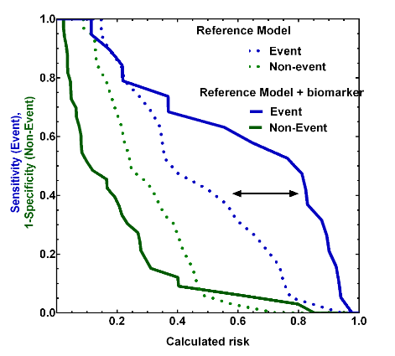2. Waikar, S.S., et al., Imperfect gold standards for kidney injury biomarker evaluation. J Am Soc Nephrol, 2012. 23(1): p. 13-21.

**Figure 1 : Risk assessment plot**